Course: Data Science Roll No: TYCS-12

Aim: Practical on Simple/Multiple Linear Regression

__________________________________________________________________________________

Outputs:

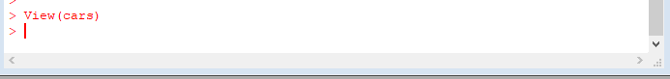

Output 1

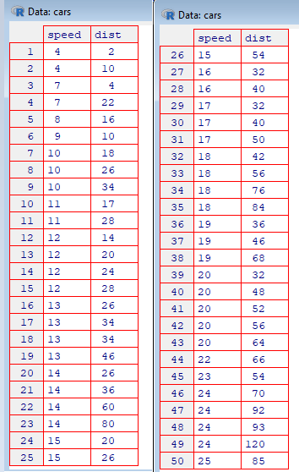

Output 2

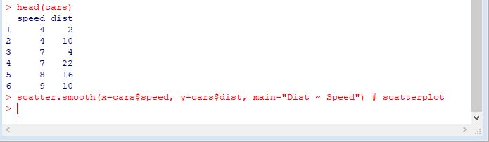

Output 3

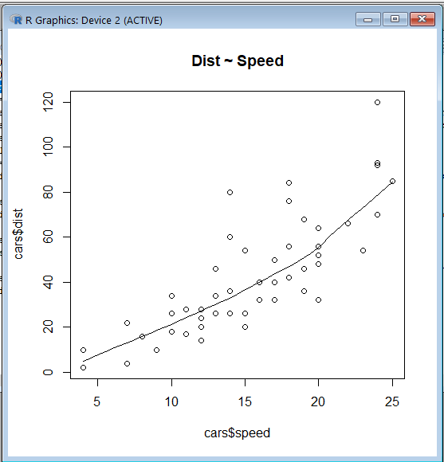

Output 4

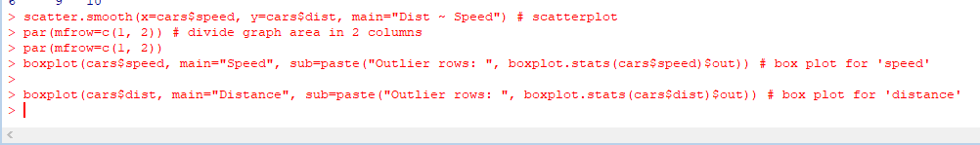

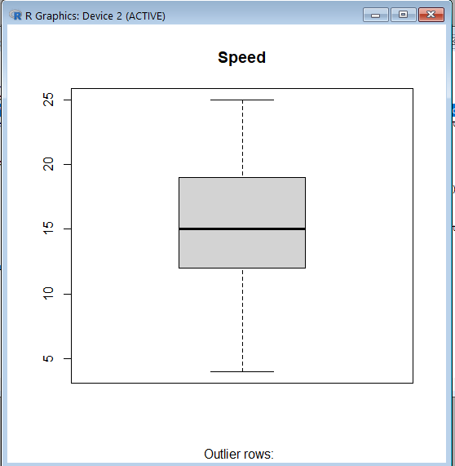

Output 5

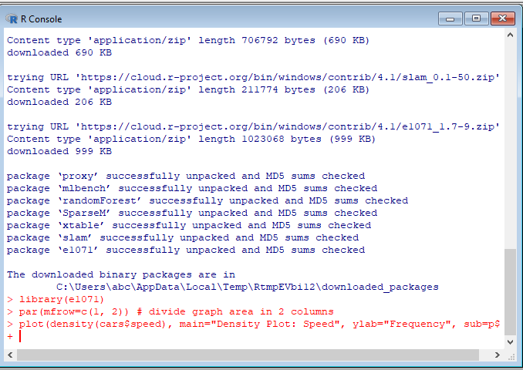

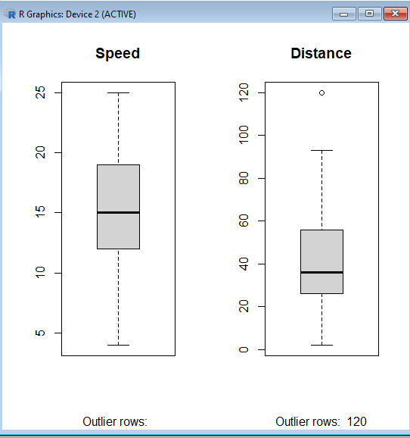

Output 6:

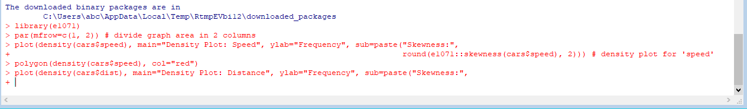

Output7

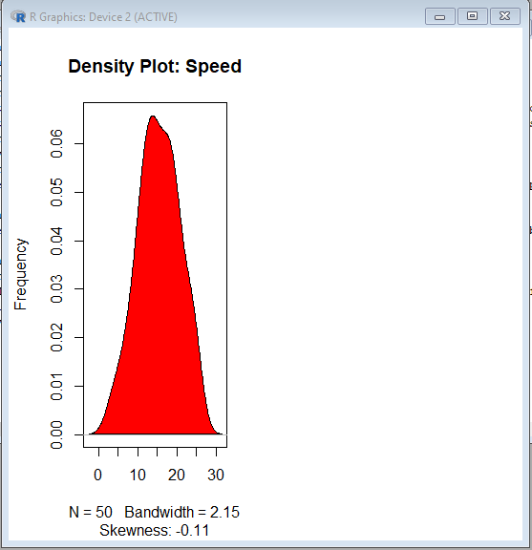

Output 8:

